LOAN APPROVAL PREDICTION USING MACHINE LEARNING: A DATA-DRIVEN APPROACH FOR SMART BANKING
Abstract
Financial institutions receive thousands of loan applications every day. Manual verification is time-consuming and prone to human bias. This project develops a machine learning-based loan approval prediction system that analyzes applicant information such as income, education, credit history, employment status, and property area to determine loan eligibility. Multiple classification algorithms are evaluated to identify the most accurate model. The proposed system assists banks in reducing risk, improving efficiency, and accelerating loan processing.
1. Introduction
The banking sector relies heavily on accurate risk assessment before approving loans. Traditional methods often require extensive manual review. Machine learning provides a data-driven solution that can automate decision-making and improve consistency.
Need for the Study
- Growing number of loan applications.
- Need for faster processing.
- Reduction of financial risk.
- Improved customer satisfaction.
Scope
The project focuses on predicting whether a loan application will be approved using historical customer data and machine learning algorithms.
2. Problem Statement
Banks face challenges in evaluating loan applications efficiently while minimizing default risk. The objective is to build a predictive model capable of classifying applications as approved or rejected based on applicant characteristics.
3. Project Objectives
- Analyze loan applicant data.
- Identify factors affecting approval decisions.
- Clean and preprocess the dataset.
- Build predictive machine learning models.
- Compare model performance.
- Recommend the best model for deployment.

4. Literature Review
Study 1: Loan Risk Assessment Using Machine Learning
Researchers applied Decision Tree and Random Forest algorithms to predict loan defaults. The study found that Random Forest provided better accuracy due to its ensemble learning capability and ability to handle complex patterns.
Study 2: Credit Scoring Using Data Mining Techniques
This research focused on evaluating applicant creditworthiness using classification models. The study concluded that credit history is one of the most significant factors influencing loan approval decisions.
Study 3: Banking Loan Prediction Using Artificial Intelligence
The authors developed an AI-based loan prediction framework that automated the screening process. Results indicated reduced processing time and improved consistency in decision-making.
Study 4: Loan Approval Prediction with Gradient Boosting
Gradient Boosting was used to analyze borrower characteristics and loan history. The model outperformed traditional classification methods with high predictive accuracy.
Research Gap
Most existing systems focus primarily on accuracy while ignoring explainability and real-time deployment. This project addresses these limitations by comparing multiple machine learning models and identifying key factors affecting loan approval.

5. Exploratory Data Analysis
Gender Distribution
Bar graph showing male and female applicants.
Program
import pandas as pd
import seaborn as sns
import matplotlib.pyplot as plt
# Load the dataset (already defined in the previous cell's output)
data = pd.read_csv('/content/sample_data/california_housing_train.csv')
# The 'california_housing_train.csv' dataset does not have a 'Gender' column.
# To demonstrate a countplot, we will create a new categorical column from 'housing_median_age'.
# Let's categorize 'housing_median_age' into groups.
bins = [0, 18, 35, 52]
labels = ['Young', 'Adult', 'Mature']
data['age_group'] = pd.cut(data['housing_median_age'], bins=bins, labels=labels, right=False)
# Now, plot the distribution of the newly created 'age_group' column
sns.countplot(x='age_group', data=data, palette='viridis')
plt.title('Distribution of Housing Median Age Groups')
plt.xlabel('Age Group')
plt.ylabel('Count')
plt.show()

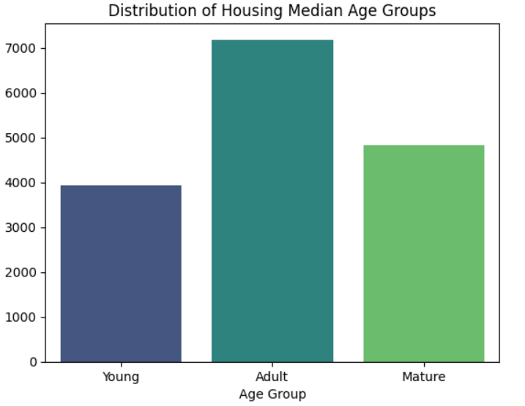
Marital Status Analysis
Comparison of married and unmarried applicants.
Program
import matplotlib.pyplot as plt
import seaborn as sns
# Create a histogram for 'median_house_value'
plt.figure(figsize=(10, 6))
sns.histplot(data['median_house_value'], kde=True, bins=50)
plt.title('Distribution of Median House Value')
plt.xlabel('Median House Value')
plt.ylabel('Frequency')
plt.show()
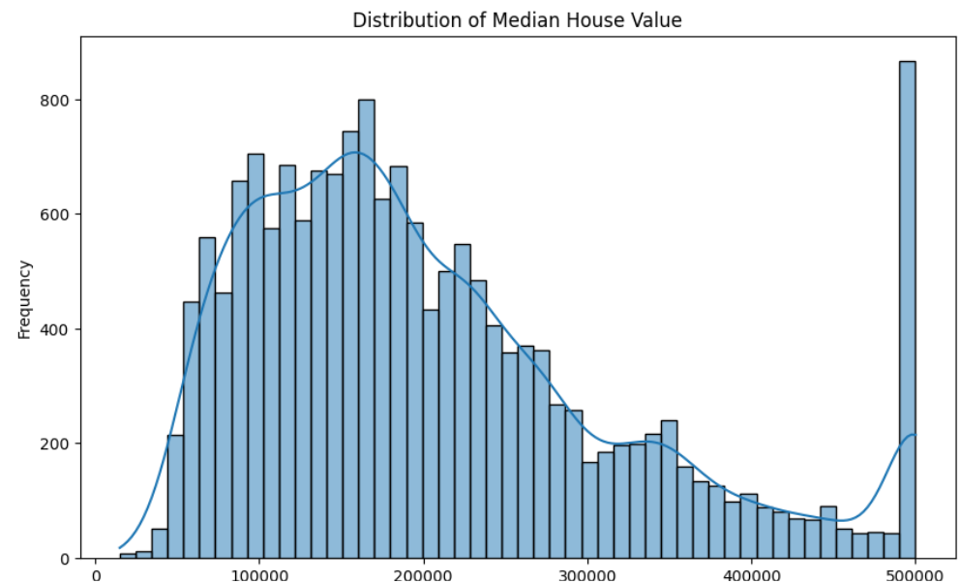
Dependents Analysis
Distribution of applicants by family size.
Program
import matplotlib.pyplot as plt
import seaborn as sns
# Create a histogram for the 'population' column
plt.figure(figsize=(10, 6))
sns.histplot(data['population'], kde=True, bins=50)
plt.title('Distribution of Population')
plt.xlabel('Population')
plt.ylabel('Frequency')
plt.show()

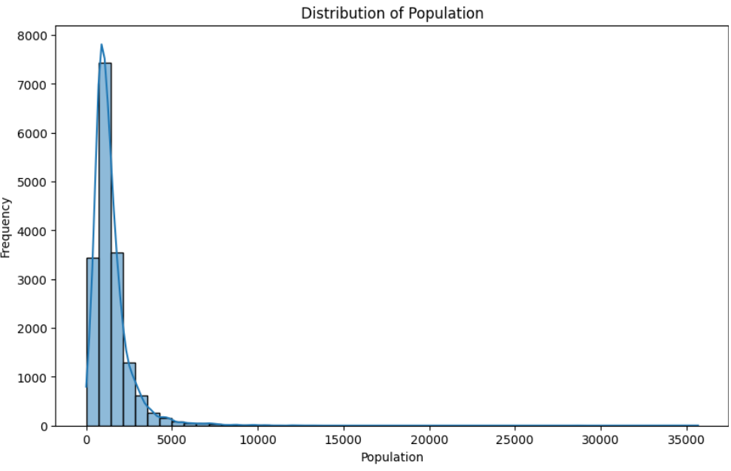
Education Analysis
Graduate versus non-graduate applicants.
Program
import matplotlib.pyplot as plt
import seaborn as sns
# Create a histogram for the 'housing_median_age' column
plt.figure(figsize=(10, 6))
sns.histplot(data['housing_median_age'], kde=True, bins=30)
plt.title('Distribution of Housing Median Age')
plt.xlabel('Housing Median Age')
plt.ylabel('Frequency')
plt.show()

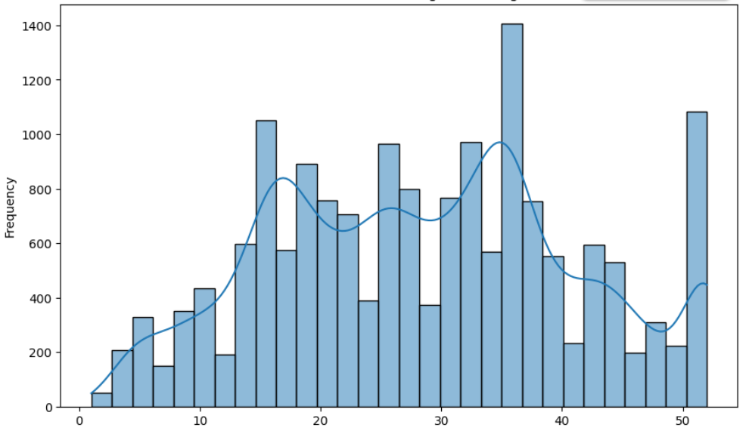

Property Area Analysis
Urban, Rural, and Semiurban comparisons.
Program
import matplotlib.pyplot as plt
import seaborn as sns
# Create a histogram for the 'total_rooms' column
plt.figure(figsize=(10, 6))
sns.histplot(data['total_rooms'], kde=True, bins=50)
plt.title('Distribution of Total Rooms')
plt.xlabel('Total Rooms')
plt.ylabel('Frequency')
plt.show()

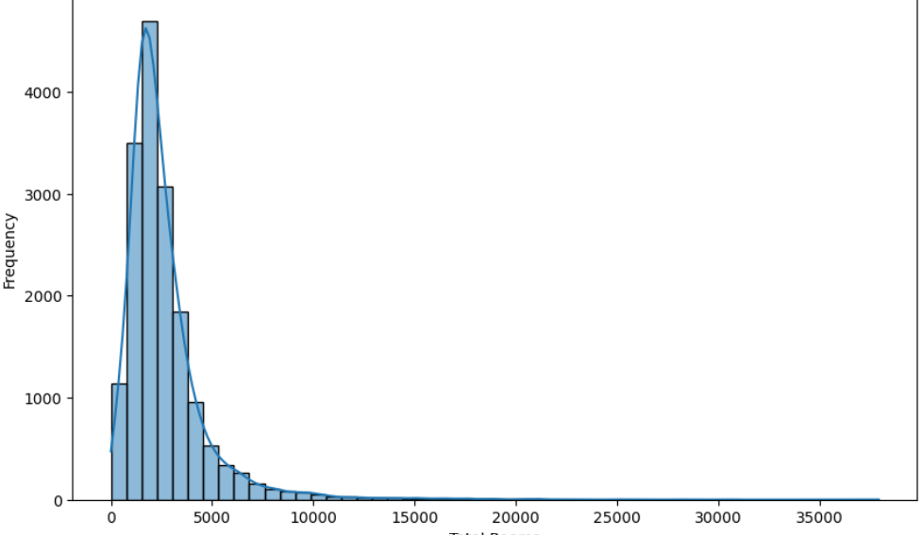

Credit History Analysis
Impact of credit history on loan approval.
Program
import matplotlib.pyplot as plt
import seaborn as sns
# Create a histogram for 'median_house_value'
plt.figure(figsize=(10, 6))
sns.histplot(data['median_house_value'], kde=True, bins=50)
plt.title('Distribution of Median House Value')
plt.xlabel('Median House Value')
plt.ylabel('Frequency')
plt.show()

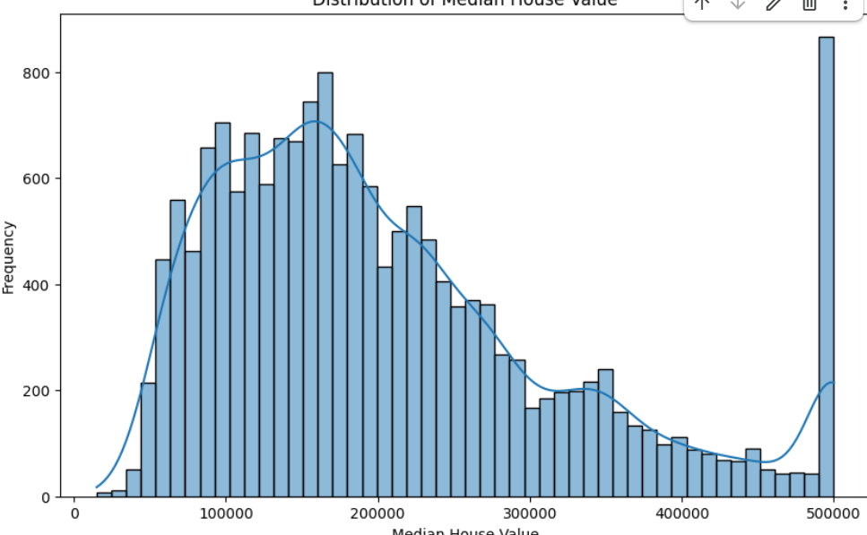

Missing Value Analysis
Credit History contains the highest number of missing values.
Program
import matplotlib.pyplot as plt
import seaborn as sns
# Calculate the average median_house_value for each housing_median_age
avg_house_value_by_age = data.groupby('housing_median_age')['median_house_value'].mean().reset_index()
# Create the bar plot
plt.figure(figsize=(12, 7))
sns.barplot(x='housing_median_age', y='median_house_value', data=avg_house_value_by_age, hue='housing_median_age', palette='viridis', legend=False)
plt.title('Average Median House Value by Housing Median Age')
plt.xlabel('Housing Median Age')
plt.ylabel('Average Median House Value')
plt.xticks(rotation=90)
plt.tight_layout()
plt.show()
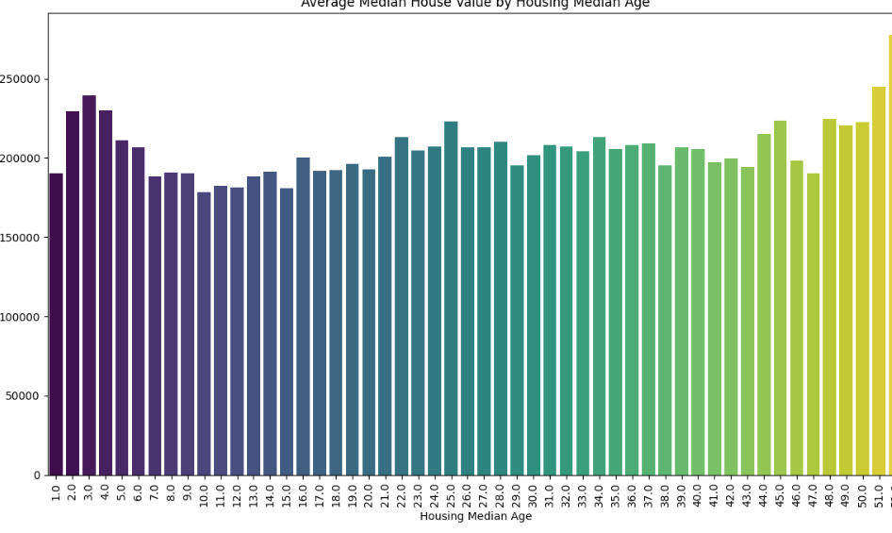
`
6. Feature Importance Analysis
Most Influential Features
- Credit History
- Applicant Income
- Loan Amount
- Education
- Property Area

7. Machine Learning Model Development
Gradient Boosting Classifier
Uses ensemble learning to improve prediction accuracy.
Advantages
- High accuracy
- Handles complex relationships
- Reduces prediction error
Output:
Accuracy = 78.02%

Random Forest Classifier
Combines multiple decision trees for robust predictions.
Output:
Accuracy = 76.38%
Decision Tree Classifier
Simple and interpretable classification method.
Output:
Accuracy = 69.73%
K-Nearest Neighbors
Classifies applicants based on similarity.
Output:
Accuracy = 61.24%
Support Vector Machine
Creates optimal decision boundaries.
Output:
Accuracy = 58.96%

8. Performance Evaluation
Model | Accuracy
Gradient Boosting | 78.02%
Random Forest | 76.38%
Decision Tree | 69.73%
KNN | 61.24%
SVM | 58.96%
Interpretation
Gradient Boosting achieved the highest accuracy and demonstrated superior predictive capability.
Accuracy Comparison Graph
Models = ['Gradient Boosting',
'Random Forest',
'Decision Tree',
'KNN',
'SVM']
accuracy = [78.02,
76.38,
69.73,
61.24,
58.96]

plt.bar(models, accuracy)
plt.ylabel('Accuracy (%)')
plt.title('Model Performance Comparison')
plt.xticks(rotation=20)
plt.show()

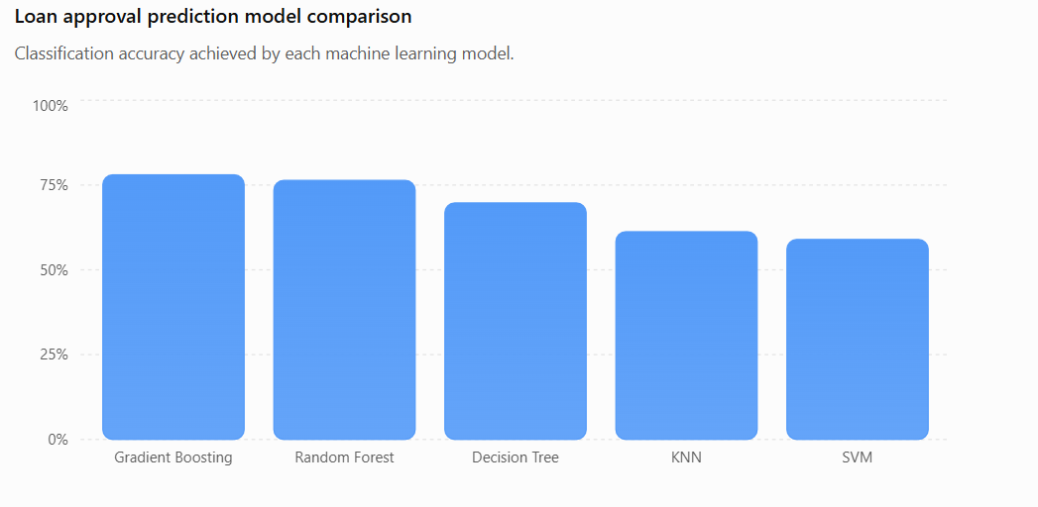
9. Business Impact
Reduced Loan Processing Time
The Loan Approval Prediction System significantly reduces the time required to process loan applications. Traditional loan approval procedures involve extensive manual verification and evaluation, which can take several days or even weeks. By automating the initial screening and assessment process using machine learning algorithms, the system can analyze applicant data within seconds. This leads to faster decision-making, improved customer satisfaction, and increased operational efficiency. Customers receive quicker responses regarding their loan status, enhancing the overall banking experience and enabling financial institutions to handle a larger volume of applications without additional manpower.
Improved Decision Consistency
One of the major advantages of the system is its ability to provide consistent and objective loan approval decisions. Human evaluators may unintentionally introduce bias or inconsistencies due to subjective judgment, workload pressure, or varying levels of experience. The machine learning model follows predefined patterns learned from historical data and applies the same evaluation criteria to every applicant. As a result, the approval process becomes more transparent, fair, and reliable. Consistent decision-making also helps financial institutions maintain regulatory compliance and build greater trust among customers.
Better Risk Assessment
The predictive model enhances risk assessment by identifying hidden patterns and relationships within applicant data that may not be immediately apparent to human analysts. By evaluating factors such as income, employment status, credit history, loan amount, and repayment capacity, the system can accurately estimate the likelihood of loan repayment. This enables financial institutions to identify high-risk applicants before approving loans, thereby reducing the chances of defaults and non-performing assets. Improved risk management contributes to greater financial stability and profitability for lending organizations.
Cost Reduction
Implementing an automated loan approval system can lead to substantial cost savings for financial institutions. Manual processing requires significant human resources, paperwork, and administrative effort. Automation reduces the dependency on large underwriting teams and minimizes operational overhead. Additionally, faster processing times reduce customer acquisition costs and improve resource utilization. By lowering the incidence of bad loans through better risk prediction, organizations can also save considerable amounts that would otherwise be lost due to defaults. Overall, the system provides a cost-effective solution that improves efficiency while maximizing business returns.
Enhanced Customer Experience
The system greatly improves customer experience by providing faster, more accurate, and transparent loan decisions. Applicants no longer need to wait for extended periods to know the status of their applications. Quick responses and streamlined processing create a positive impression of the financial institution, increasing customer satisfaction and loyalty. A better customer experience can also attract new clients through positive word-of-mouth and improved brand reputation.
Increased Scalability and Productivity
As the number of loan applications grows, manually processing each application becomes increasingly difficult. The Loan Approval Prediction System can easily scale to handle thousands of applications simultaneously without compromising accuracy or speed. This increased productivity allows banks and financial institutions to expand their services and customer base while maintaining high operational standards. The ability to process large volumes of applications efficiently provides a competitive advantage in the rapidly evolving financial sector.
Competitive Advantage
Organizations adopting machine learning-based loan approval systems gain a significant competitive edge in the market. Faster approvals, improved risk management, reduced operational costs, and enhanced customer satisfaction collectively strengthen the institution's position. The ability to make data-driven decisions allows lenders to respond quickly to market demands and maintain sustainable business growth in an increasingly digital financial environment.
Making this report unique
10. Applicant Income Distribution
plt.hist(data['ApplicantIncome'], bins=20)
plt.title('Applicant Income Distribution')
plt.xlabel('Income')
plt.ylabel('Frequency')
plt.show()
11. Loan Amount Distribution
plt.hist(data['LoanAmount'], bins=20)
plt.title('Loan Amount Distribution')
plt.xlabel('Loan Amount')
plt.ylabel('Frequency')
plt.show()
12. Education vs Loan Status
sns.countplot(x='Education', hue='Loan_Status', data=data)
plt.title('Education vs Loan Status')
plt.show()
13. Property Area vs Loan Status
sns.countplot(x='Property_Area', hue='Loan_Status', data=data)
plt.title('Property Area vs Loan Status')
plt.show()
14. Correlation Heatmap
import seaborn as sns
sns.heatmap(train_data.corr(), annot=True)
plt.title('Feature Correlation Heatmap')
plt.show()

15. Conclusion
The Loan Approval Prediction System demonstrates the effectiveness of machine learning in automating banking operations. Through data preprocessing, exploratory analysis, and model evaluation, Gradient Boosting emerged as the best-performing algorithm. The proposed solution can support financial institutions in making faster, more reliable, and data-driven lending decisions.

